Online Safety Newsletter

October 2023

Does your child watch livestreams?
Parental Controls

Does your child have a games console? If yes, have you set up age-appropriate parental controls? The controls vary across the different consoles, but all will allow you to restrict spending and communication for example.

PlayStation
Set up your account as a family manager and create a separate child account so you can tailor their activities. Find out more here:
https://www.playstation.com/en-gb/support/account/psn-safety-parents-guide/

Xbox
You can download an app to manage your child’s gaming experience. Find out more here:
https://www.xbox.com/en-GB/apps/family-settings-app

Nintendo Switch
Nintendo also offer a free app to monitor what and how your children are playing. Find out more here: https://www.nintendo.co.uk/Nintendo-Switch-Family/Nintendo-Switch-Parental-Controls/Nintendo-Switch-Parental-Controls-1183145.html

What is livestreaming?
Livestreaming is when an individual broadcasts video live over the internet. People can watch livestreams from any device that is connected to the internet.

Who is watching livestreaming?
Research from Ofcom reported that 57% of 3 – 17 year olds have watched live streams and the most used platforms to watch live streams were YouTube and TikTok. The research also showed that the percentage watching content on livestreaming app/sites increased by age. A third of 3-4 year olds were watching live content with this number growing to eight in ten of 16-17 year olds. This is reported in Children and parents: media use and attitudes report 2022 (ofcom.org.uk).

What are the risks?
There are risks associated with watching livestreams that you should be aware of. The main risk being that your child may see or hear something inappropriate as your child may come across themes or content that is not suitable for them. It is difficult to moderate live content as it is happening in real time.

How can I help my child?
- All online platforms have an age rating, ensure your child only accesses platforms that are appropriate to their age. For example, TikTok has an age rating of 13.
- For any platforms that your child uses, ensure appropriate parental controls and privacy settings are applied.
- Take an interest in what your child is doing online and on a regular basis, ask your child to show you what they are accessing.
- Ensure your child knows how to use any reporting/blocking tools on the app that they are using and as always please ensure that your child knows to talk to a trusted adult if they see anything that concerns them online.

Further information
- https://www.childnet.com/help-and-advice/livestreaming-parents/
- https://www.thinkuknow.co.uk/parents/articles/what-is-live-streaming/
Users of this guide do so at their own discretion. No liability is entered into. Current as of the date released 1.10.23.

Skill-building app suggestions from Internet Matters

Internet Matters have curated a list of apps that will help your child to develop skills and new interests in different areas, for example Game Builder Garage (7+), which helps children to create their own games and Tayasui Sketches to develop art skills. You can find the full list here:

https://www.internetmatters.org/resources/skill-building-apps-guide-for-kids/

Playing games online

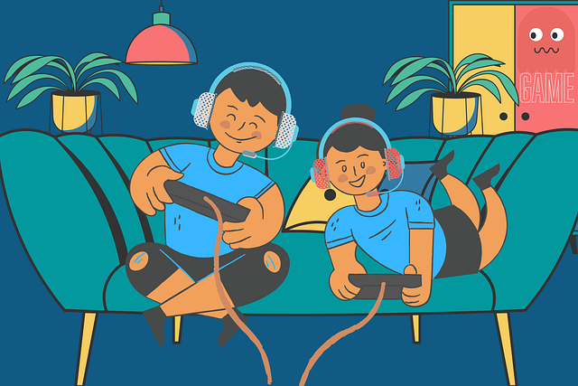
Does your child play games online? We have outlined some points that you may wish to consider to try and create a safer experience for your child.

Have you set up parental controls?
As well as setting up appropriate parental controls through the game’s setting, ensure you have set them up on the console/device your child is playing on. For example, many consoles allow you to restrict the games accessed by age.

Scary Teacher 3D

Scary Teacher 3D is a game rated as 12+ by the App store (due to Mild Realistic Violence) or as ‘Teen’ on Google Play (due to violence). The game does include in-app purchases as well. Players must scare their teacher by completing different activities. There are lots of videos of this game on YouTube as well.

As with all games your child is asking to play, please take note of the age rating and play the game first to see if you think it is appropriate for your child.

Chatting to strangers
Some games will allow communication, for example (FIFA and Fortnite). Depending on the game, this may be via the in-game text chat, direct messages or talking through headphones. Some games do offer the ability to switch communication off or restrict bad language so make sure settings appropriate to your child are set up for each of the games they play.

It can be difficult to moderate online chat so ensure your child knows how to block and report other players who make them feel uncomfortable and that they know to talk to you or a trusted adult if they have any concerns. It can also be very easy online for children to behave in a way that they would not if they were face to face with each other. Talk to your child about how they are speaking to others online and encourage them to talk to people online with respect, like they would if they were face-to-face.

Is the game age appropriate?
Before buying the game, check that your child is old enough to play it. All games will either have a PEGI rating or be rated by the App Store /Google Play. UK Safer Internet Centre have published a blog, which shares tips on what to do if your child asks about playing a new game:

Teaching children about money

Lloyds bank have published information and resources to help us help our children develop good financial habits. The information is split into age groups so you can find support tailored to your child’s age. You can find out more here:

https://www.lloydsbank.com/help-guidance/family-finances/teaching-children-about-money.html

- https://saferinternet.org.uk/blog/help-my-child-wants-to-play-games-that-are-too-old-for-them-2

In app purchases
In addition to the above, you should be aware of in app purchases as lots of games include the option to purchase additional items/subscriptions so ensure you do not have payment cards saved or set up restrictions/pin code to approve.

Further information
The NSPCC provide further guidance and support regarding this topic:

- https://www.nspcc.org.uk/keeping-children-safe/online-safety/online-games/

